 | HVAC WORK ORDER  Alder Residence — Portland, OR

Customer | Casey Alder
Address | 1234 SE Alder St, Portland, OR 97215
Phone | (503) 555-0136
Questions on site | Kyle — (503) 555-0117
Job # | 2026-0714
Install Dates | ___________________________
Crew Lead | ___________________________
⚠ SAFETY FLAGS: LEAD PAINT — 1962 home, lead-safe (RRP) practices on any paint disturbance
Scope of Work
Task | Details | Location
Remove gas furnace | Cap gas at the appliance, remove furnace + attic duct runs, haul away | Hall closet + attic
Install ductless heat pump | 24k cold-climate outdoor unit on east wall pad, 12k wall head (living), 9k wall head (bedroom), linesets through attic | East wall, living room, bedroom
Range hood duct | Duct new 300 CFM hood through upper cabinet, out the wall cap with damper | Kitchen
Bath fan | ENERGY STAR 110 CFM fan with humidistat, duct out the roof, first 3 ft straight | Hall bath
Equipment Arriving
Item | Model | Qty
Outdoor unit | 24k cold-climate ductless ODU | 1
Wall heads | 12k (living) + 9k (bedroom) | 2
Bath fan | 110 CFM ENERGY STAR, humidistat | 1
Range hood | 300 CFM ducted | 1
Disconnect + whip | 60A non-fused | 1
Burch QA — Heat Pump Installation (Ductless)
☐ All indoor heads mounted and connected (Q81)
☐ All zones tested in heat AND cool mode (Q82)
☐ Manufacturer remotes/controls operational for each zone (Q83)
☐ ODU installed on permanent pad, stable, level, secured (Q75-76)
☐ Line set length recorded + insulation covers the full run (Q78, Q80)
☐ Condensate drains sloped and terminated clear of the building (Q79)
Burch QA — Commissioning Diagnostics
Test | Value | Pass?
HP Airflow (CFM) | ________ | ☐
CFM/ton (target 350-400) | ________ | ☐
Supply static pressure (in. WG) | ________ | ☐
Return static upstream of filter (in. WG) | ________ | ☐
Return static downstream of filter (in. WG) | ________ | ☐
Pressure pan test — avg < 1.5, no single > 2 (Q60) | ________ | ☐
Room pressurization — no room > 3 Pa (Q62) | ________ | ☐
Burch QA — Bath Exhaust Fans
☐ Fan flow: 20+ CFM continuous OR 50+ CFM intermittent (Q88)
☐ ENERGY STAR certified (Q89)
☐ Automated controls — timer or humidistat (Q90)
☐ Duct terminates OUTDOORS — clear of attic, crawl, and floor cavities (Q91)
☐ First 3 feet of duct off the fan run straight (Q92)
☐ Outlet 10+ ft from any air inlet (Q93)
☐ All duct seams sealed mastic/UL-181 (Q94)
☐ Wall cap includes damper (Q95)
Burch QA — Kitchen Exhaust Fan
☐ Minimum 100 CFM measured flow (Q97)
☐ ENERGY STAR certified (Q98)
☐ Vents outdoors on the direct route, no bends first 3 ft (Q99)
☐ Duct seams sealed mastic/UL-181 (Q101)
☐ Wall cap includes damper (Q102)
Permits
☐ Permits closed out for EACH inspected installed measure (Q162)
☐ Permit finals scheduled BEFORE requesting the program QA inspection
☐ Inspection cards / permit numbers photographed for the job file
Burch QA — Homeowner Education (leave-behind)
☐ Occupant informed: run the heat pump as primary — backup ER heat costs more (Q111)
☐ Occupant informed: nighttime setback 4°F or less (Q112)
☐ Occupant informed: use "heat" or "cool", leave "auto" alone (Q113)
☐ Occupant informed: fan speed on "automatic" (Q114)
☐ Occupant informed: filter replacement schedule (Q115)
Notes for Crew
• Homeowner is on video calls in the back office — knock at the front door, headphones mean go around
• Keep the driveway clear of material staging after 4pm (street sweeping Tuesday)
• Cat is friendly and sneaky — check for her before closing the attic hatch
Reference Photos
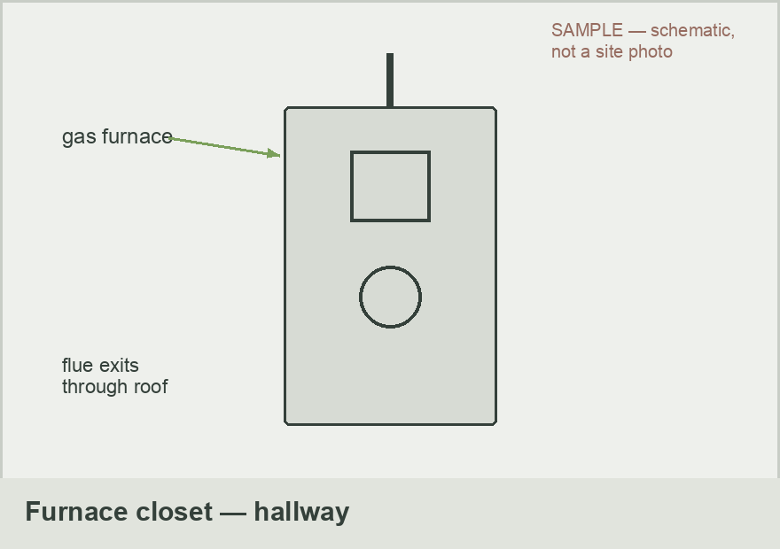 | 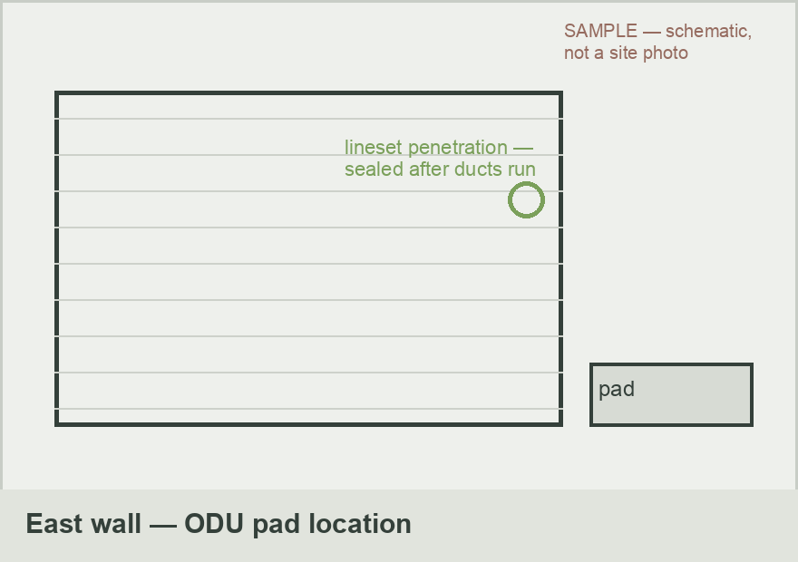
Furnace closet, hallway — gas capped at the appliance Day 1 | East wall ODU location — pad here, lineset penetration sealed after ducts run
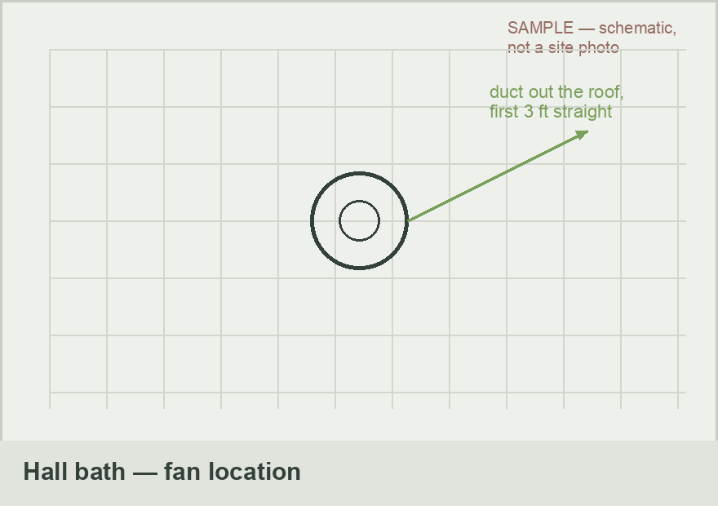 | 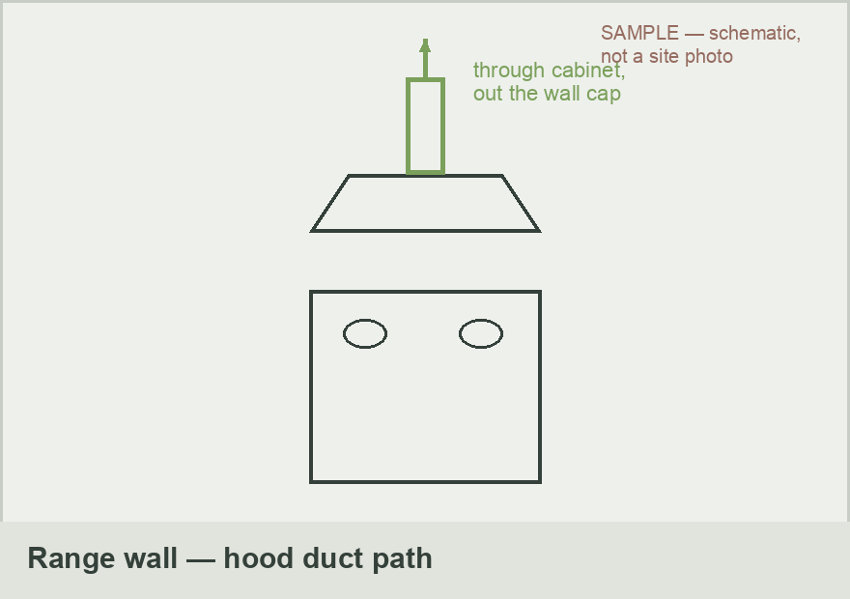
Hall bath fan location — duct out the roof, first 3 ft straight | Range wall — hood ducts through the upper cabinet, out the wall cap

Resilient Retrofits · CCB# 245539 · Prepared by: Kyle Kanooth

